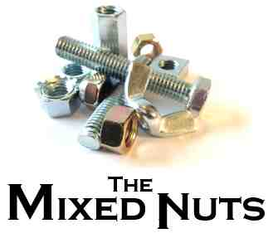
Lindy Hop Last revised on 2017.05.24
Re-sequenced on 2017.05.11
LH01-Bless You For The Good That's In You(KVD).pdf
LH02-12th Street Rag(K).pdf
LH03-Route 66(KV).pdf
LH04-American Patrol(K).pdf
LH05-Pennsylvania 6-5000(K).pdf
LH06-Joshua Fit The Battle Of Jericho(K).pdf
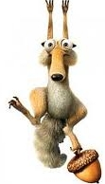
LH07-Swing Low, Sweet Chariot(K).pdf
LH08-Rock Around The Clock(KVF).pdf
LH09-Boogie Woogie Bugle Boy(KVF).pdf
LH10-Hound Dog(KV).pdf
LH11-Alright, OK, You Win(KVF).pdf

LH12-Baby Face(KVF).pdf
LH13-Choo Choo Ch'Boogie(KVF).pdf
LH14-Back Home Again In Indiana(KVF).pdf
LH15-Bandstand Boogie(K).pdf
LH16-Sing, Sing, Sing(K).pdf
LH17-Gotta Be This Or That(KVF).pdf
LH18-Don't Be That Way(K).pdf
LH19-In The Mood(K).pdf
LH20-Muskrat Ramble(K).pdf
LH21-Stompin' At The Savoy(K).pdf
LH22-Three Little Fishies(KV).pdf
LH23-'Taint What You Do(KVF).pdf
LH24-Jump, Jive, And Wail(KV).pdf
LH25-Boogie Blues(KV).pdf
LH26-Yes Sir, That's My Baby(KV).pdf
LH27-Dipsy Doodle(KVF).pdf
LH28-Rag Mop(KVF).pdf
LH29-Little Brown Jug(K).pdf
LH30-One O'Clock Jump(K).pdf
LH31-It Don't Mean A Thing(KVF).pdf
LH32-Tiger Rag(K).pdf
LH33-Chattanooga Choo Choo(KVF).pdf
LH34-Shiny Stockings(KVF).2017.05.24.pdf
LH34-Shiny Stockings(KVM).2017.05.24.pdfLH35-Perdido(KV).pdf
LH36-Bill Bailey(KVF).pdf
LH37-That's A-Plenty(K).pdf

